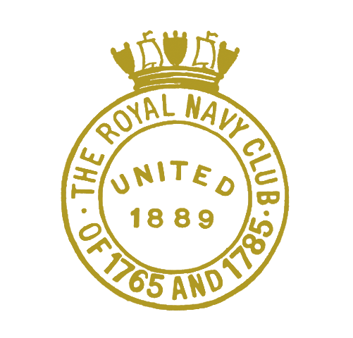
THE ROYAL NAVY CLUB OF 1765 AND 1785
(UNITED 1889)

DRAFT MINUTES
of the ANNUAL GENERAL MEETING 2023
held in the Royal Maritime Club, Portsmouth, on Thursday 7th September 2023 at 1730

39 Members attended: 19 in person and a further 20 connected by VTC ZOOM;

Admiral Sir Philip Jones (Chairman), chaired the AGM
The Secretary, Commander B P Boxall-Hunt, was in attendance.

In opening the Annual General Meeting 2023, his first since succeeding Vice Admiral Sir Charles Montgomery, the Chairman bid a warm welcome both to those in the Nelson Lounge of the Royal Maritime Club and to all those who had joined on line through ZOOM VTC. It was once again a very encouraging turnout under the new format with plenty of scope, it is hoped, to include far more attendees at future AGMs.

1. The Minutes of the Annual General Meeting 2022 were confirmed and signed.
2. Matters arising. There was none.
3. Chairman’s Report. Admiral Sir Philip Jones drew attention to his Chairman’s Annual Report, which had been mailed to all members and sought to draw out the key points. He reflected that the Club had emerged from the Covid pandemic in good heart, had enjoyed a positive dinner programme overcoming several challenges, and finances were in good shape. Planned dinners onboard HQS WELLINGTON and HMS PRINCE OF WALES had to be changed at relatively short notice to alternative venues but had each in turn been successful: he stressed that the Committee had not in any way given up on the idea of dining onboard an aircraft carrier alongside when available. The Club was returning to the West Country in October for Trafalgar Night at BRNC Dartmouth and much looking forward to it. Membership continued a gentle decline with some deaths and resignations, although new membership was growing amongst the Lt Cdr and female officer cohorts. The Financial Year 2022/23 had seen the return to normality after the COVID pandemic during which the Club had been forced to cancel 4 dinners, and as a deliberate policy a more expensive dinner programme as a treat had been held to spend some of the accrued money which together with 4 more prizes purchased the General Fund ended in a planned deficit of £9575. It had been decided to make a small increase in dinner charges and annual subs after 10 years at current levels although remaining very much affordable and good value for money. Our charitable objects had been met in full although, at 3, in support of a reducing number of memorialists. Both of our funds, General and Surplus, remained fit for purpose. There were no questions.

4. General Fund Accounts. The Secretary presented the General Fund Accounts for 2022/23 drawing attention to the “clean audit” achieved, with no pick-up points. Cash held throughout the year had been healthy and there were no debtors. The end of Financial Year result saw a planned deficit of some £9,575 as a result of a deliberate policy to have 3 more expensive dinners to counter balance the “famine” of pandemic years. Expenditure was tightly controlled, but had allowed the purchase of 4 more polished brass sextants for annual Club prizes. In view of the General Fund deficit and corresponding surplus in the Surplus Fund, unusually no grant been transferred to the Surplus Fund this time. In summary a satisfactory year with all aims met, all bills paid, cash healthy and books balanced. Forecast for the following year was a break-even, or minor surplus. A copy of the approved and signed audited accounts had been posted on the website. Overall, the General Fund finances were in good order. The Chairman thanked the Secretary for his report.

5. Surplus Fund Accounts. The newly appointed Chairman of Trustees, Commodore Mike Wallicker, having succeeded Rear Admiral Niall Kilgour, reported that the Surplus Fund was in a healthy condition. The latter continued as a Trustee, with Rear Admiral Iain Henderson remaining as Vice Chairman. The audit had again been “clean” with a healthy surplus of £7,070 at year end. Investment values and income was returning slowly to pre- Ukraine war levels, with the latter at £42,000 being 3.14% of portfolio value. Cashflow was satisfactory and in year finances sound, with around £70,000 in the bank. The Surplus Fund continued to be in good health and a “going concern”, achieving its charitable aim, but his plea was for members to continue to keep a good lookout for potential beneficiaries needing our help as memorialists receiving our grants were now reduced to 3 all of which well over 80 years old. He ended by thanking the Secretary for his sterling support for the Surplus Fund, memorialists and Trustees over the financial year.
The Chairman thanked him for his report and asked for questions on either fund: there were none.

6. Members in Arrears of Subscription. The Secretary reported that there was none who yet qualified under Rule IV.

7. Amendments to Club Rules. There were no amendments proposed.

8. Appointment of Independent Examiner. A resolution to re-appoint Mr Malvern Carvell for a further year as Independent Examiner was proposed by Cdre Mike Beardall, seconded by Cdre Dick Twitchen and agreed unanimously.

10. Any Other Business.
There was no other business raised. In closing the AGM, the Chairman wished to record his immense gratitude to all those who have served as either committee members or trustees during the year, and to the Secretary. He encouraged Fellow Officers to engage with respective Committee Members who were listed on the website, as feedback from members was very important.

Commander B P BOXALL-HUNT OBE Royal Navy Admiral Sir Philip Jones GCB DL

Secretary Chairman

